Contact me in order to access the whole complete document. //Email: solution9159@gmail.com //
WhatsApp: https://wa.me/message/2H3BV2L5TTSUF1 // Telegram: https://t.me/solutionmanual

Chapter 1

The Principles and Practice of Economics

Questions
- Give examples to explain how economic analysis can be positive and normative.
Answer: Positive economics is objective and based on facts. However, normative economics is subjective and opinion based. For example:
Positive: The mismatch between students’ knowledge and the market requirements is a factor underlying low employability.
Normative: The government should increase the minimum wage earned by each employee.
- Economics studies the allocation of scarce resources for unlimited wants. Explain this statement and identify how economics can apply to individuals, firms, and nations.
Answer: Individuals, firms, and nations face scarcity. Individuals have limited budgets (scarce resources) compared to their unlimited wants that they wish to satisfy. Firms have unlimited investment projects as compared to their limited budgets. Nations may have many areas—growth, human development, healthcare, legislature, education etc.—that require expenditure, but due to limited budgets the governments need to prioritize.
Scarcity of resources for individuals, firms, and nations compared to their unlimited wants pushes them to make choices by allocating scarce resources to desired wants. Economics is a science which helps in performing this allocation.
- Examine the following statements and determine if they are normative or positive in nature. Explain your answer.
- The U.S. automotive industry registered its highest growth rate in 5 years in 2012; U.S. auto sales increased by 13% compared to 2011.
- The U.S. government should increase carbon taxes to control emissions that cause global warming.
Answer:
- This is an objective statement about the rate of growth in the U.S. automotive industry. Positive economics is analysis that generates objective descriptions or predictions about the world that can be verified with data. Since data can be used here to verify the rate of growth and whether it is the highest in five years, this is a positive statement.
- The statement that the government should increase carbon taxes to control emissions is normative since it states what the government ought to do. Normative economics advises individuals and society on their decisions and is almost always dependent on subjective judgments.
- Differentiate the following—population, national income, firm’s production, economic growth, consumer budget, unemployment rate, national production, government spending, and inflation—based on whether they would be studied under microeconomics or macroeconomics.
Answer: Microeconomics studies economic behavior of individuals and firms and their relationship with product and factor markets when making choices in consumption, production, prices and income. Therefore, among all these examples, the firm’s production and consumer budget would be studied under microeconomics.
Macroeconomics focuses on aggregate economic variables. Therefore, population, national income, economic growth, unemployment rate, national production, government spending, and inflation would be studied under macroeconomics.
- What does a budget constraint represent? How do budget constraints explain the trade-offs that consumers face?
Answer: A budget constraint is an equation representing the goods or activities that a consumer can choose given her limited budget. Tradeoffs arise when some benefits must be given up in order to gain others. In other words, a tradeoff occurs when you give one thing up to get something else. Since a budget constraint shows the set of things that you can choose to do or buy with a fixed amount of money, it also shows that if you choose to buy more of one good, you will have to buy less of another. Therefore, a budget constraint equation implies that a consumer faces a tradeoff.
- This chapter introduces the idea of opportunity cost.
- What is meant by opportunity cost? How are the opportunity costs of various choices compared?
- What is the opportunity cost of taking a year after graduating from high school and backpacking across Europe? Are people who do so being irrational?
Answer:
- Opportunity cost is the best alternative use of a resource. The opportunity cost of a particular choice is measured in terms of the benefit foregone from the next best alternative. To facilitate comparison, the benefits and costs of various choices are translated into monetary units like dollars.
- The opportunity cost of backpacking across Europe, for a particular person, is the cost of anything else that could have been done in that year. The backpacker could have attended college or started working. These costs are the opportunity costs of the gap year. This, however, does not mean that backpackers are irrational, because the benefits may exceed the cost. Every action has an opportunity cost. The choices that people make are optimal based on their perceived costs and benefits.
- Suppose your New Year’s resolution is to get back in shape. You are considering various ways of doing this; you can sign up for a gym membership, walk to work, take the stairs instead of the elevator, or watch your diet. How would you evaluate these options and choose an optimal one?
Answer: You can use cost-benefit analysis to compare the various feasible alternatives and pick the best one. Cost-benefit analysis is a calculation that adds up costs and benefits using a common unit of measurement, like dollar values. The costs and benefits of using the gym, walking, taking the stairs, or dieting need to be converted into dollar values. This will include monetary as well as opportunity costs. You can then choose the option that offers you the greatest net benefit.
- Suppose the market price of corn is $5.50 per bushel. What are the three conditions that will need to be satisfied for the corn market to be in equilibrium at this price?
Answer: For the market to be in equilibrium, three conditions will need to be satisfied.
- At the price of $5.50 per bushel, the amount of corn produced by sellers should be equal to the amount of corn purchased by buyers in the market.
- Farmers have chosen the optimal quantity of corn to produce given the price of $5.50 per bushel.
- Consumers have chosen the optimal quantity of corn to buy given the price of $5.50 per bushel.
- Economists are often concerned with the free-rider problem.
- What is meant by free riding? Explain with an example.
- Are public parks subject to the free-rider problem? What about keeping city streets clean? Explain your answer.
Answer:
- A free rider is a person who receives the benefit of a good but avoids paying for it. People tend to pursue their own private interests and usually don’t contribute voluntarily to the public interest. For example, watching a pirated copy of a movie is cheaper than buying one. Those who watch the pirated version are essentially free riders because there are others who buy the movie or pay for movie tickets. If everyone watched pirated copies, making movies would not be profitable and the industry would not function.
- Cleaning of city streets may be subject to free riding. Suppose the streets are cleaned every day at a fixed cost. This cost is borne by those who pay taxes to the city government. However, they cannot prevent others who do not pay taxes from using the clean streets. This leads to the free rider problem. Public parks, however, can avoid the free rider problem by setting an entrance fee. This means that only those who pay toward the maintenance and upkeep of the park will be able to use it.
- Scarcity exists because people have unlimited wants in a world of limited resources. Explain this statement by giving a real-life.
Answer: Since the world has limited resources, no one can have everything they want. For example, you have a given income that you would allocate to buy different things. You choose how much of this income you will allocate to buy clothes, how much of this income you will allocate to buy a car and how much from this income to travel and spend vacations. Due to you limited budget you will face a scarcity problem.
- Identify the cause and the effect in the following examples:
- Lower infant mortality and an improvement in nutrition
- A surge in cocoa prices and a pest attack on the cocoa crop that year
Answer:
- An increase in nutrition is likely to lead to or cause lower infant mortality.
- The pest attack is likely to have reduced the cocoa crop, leading to a rise in prices.

Problems
- In an episode of the sitcom Seinfeld, Jerry and his friends Elaine and George are waiting to be seated at a Chinese restaurant. Tired of waiting, Elaine convinces the others that they should bribe the maître d’ to get a table.
- What factors should they consider when they are deciding how high to make their bribe?
- Jerry, Elaine, and George had tickets for a movie after dinner. How would this have affected the amount that they were willing to pay as a bribe?
- The amount that they finally decide to pay is higher than the value of the meal that they would have had. Does this mean that they are being irrational?
Answer:
- They should consider the opportunity cost of the time that they will have to spend waiting to get a table. This calculation would depend on how much they value the best alternative activity that they could have been doing instead of waiting.
- The fact that they had to catch a movie would have increased their opportunity cost of waiting.
- Not necessarily.Given that they had already been waiting for a while and had to catch a movie after dinner, it’s possible that they placed a very high value on the time that they spent waiting for the table.
Adapted from http://yadayadayadaecon.com/clip/10/
- You are thinking about buying a house. You find one you like that costs $200,000. You learn that your bank will give you a mortgage for $160,000 and that you would have to use all of your savings to make the down payment of $40,000. You calculate that the mortgage payments, property taxes, insurance, maintenance, and utilities would total $950 per month. Is $950 the cost of owning the house? What important factor(s) have you left out of your calculation of the cost of ownership?
Answer: You have ignored the opportunity cost of the funds you are using for the down payment. By using your $40,000 to buy the house, you give up the opportunity to earn interest on that money. If you could earn 5% interest, then the opportunity cost is 0.05 x $40,000 = $2,000 per year, or $167 per month. This does not imply that you should not buy this house. It does imply, however, that you need to think carefully about opportunity cost as you weigh this decision.An economist would tell you that the monthly cost of owning this home is $950 + $167 = $1,017.
- What is meant by equilibrium? Give a real life example.
Answer: Equilibrium can be defined as a situation in which nobody would benefit from changing his or her own behavior and cannot do better by moving to another alternative. So, in an equilibrium situation each agent is optimizing. Suppose that the market for oranges is displaying an equilibrium price of $2 per kilogram. This equilibrium situation means that both buyers and sellers are satisfied of this price, the quantity exchanged on the market and no one would change his or her situation. With this price, each agent is optimizing.
- By taking the train, Alain can travel from Paris to Lille in one hour. The same trip takes 5 hours by bus. The train costs €80 and the bus €20. When Alain is not traveling he can work and earn €25 per hour.
a. What is the opportunity cost for Alain of travelling by bus and by train?
b. What will be the answer if another person chooses not to travel and to work for €10 per hour?
Answer:
a. The opportunity cost of the bus = 20 + (5× 25/hour) = €145. The opportunity cost for the train is 80 + (1 × 20) = €100.
b. The opportunity cost of the bus = 20 + (5 × 10/hour) = €70. The opportunity cost for the train is 80 + (1 × 10) = €90.
- There is an old saying that "The proof of the pudding is in the eating," which means that by definition good decisions work out well and poor decisions work out badly. This question asks you to consider this the wisdom of this saying.
- Your friends live in a city where it often rains in May. Nonetheless, they plan a May outdoor wedding and have no backup plan if it does rain. The weather turns out to be lovely on their wedding day. Do you think your friends were being rational when they made their wedding plans? Explain.
- You usually have to see a doctor several times each year. You decided to buy health insurance at the start of last year. It turns out you were never sick last year and never had to go the doctor. Do you think you were being rational when you decided to buy health insurance? Explain.
- Given your answers to the first two parts of this question, do you agree or disagree that "The proof of the pudding is in the eating?" Explain.
Answers:
- Your friends probably have not optimized, i.e. they were not rational. There was a good chance of rain on their wedding day and they had no backup plan if it did rain. Given the information available when they made their plans, they made a poor decision.
- You probably were being rational when you bought health insurance. You usually have to see a doctor several times each year and without insurance you would have to pay for those visits to the doctor. Given the information available when you made your plan, you made a good decision.
- Sometimes the proof is not in the pudding. Sometimes poor decisions work out well (your friends live in a rainy city but planned an outdoor wedding); sometimes good decisions work out poorly (you bought health insurance that you never used.
- Consider the following three statements:
- You can either stand during a college football game or you can sit. You believe that you will see the game very well if you stand and others sit but that you will not be able to see at all if you sit and others stand. You therefore decide to stand.
- Your friend tells you that he expects many people to stand at football games.
- An economist studies photos of many college football games and estimates that 75 percent of all fans stand and 25 percent sit.
Which of these statements deals with optimization, which deals with equilibrium, and which deals with empiricism? Explain.
Answer:The first statement involves optimization. You believe that you will be best off if you stand regardless of the decisions other people make. The second statement involves equilibrium. If many other people also reason as you did then we should expect many people will decide to stand. The third statement involves empiricism. Our theory tells us that we should expect many people to stand at games. This economist’s empirical study supports the theory.
- A sales manager is making a decision on whether to install a new computer-based processing system. He is aware that computerization sales will give a higher reliability and therefore an increase of sales of about $500 monthly for 5 years. At the same time, implementing the new computerized system will induce $20,000 installation costs, cabling costs of $1,000, and training costs of $4,000. Make a cost-benefit analysis to help the sales manager in making his decision.
Answer: The cost-benefit analysis requires an evaluation of the costs of the project to be implemented and the benefits that the sales manager will gain. The costs of implementing the project are estimated to $20,000 + $1,000 + $4,000 = $25,000. The benefits gained from the project in 5 years will be $500 × 12 × 5 = $30,000. Therefore, the manager should implement the project.
- This chapter discussed the free-rider problem. Consider the following two situations in relation to the free-rider concept.
- The Taft-Hartley Act (1947) allows workers to be employed at a firm without joining the union at their workplace or paying membership fees to the union. This arrangement is known as an open shop. Considering that unions negotiate terms of employment and wages on behalf of all the workers at a firm, why do you think that most unions are opposed to open shops?
- For your business communication class, you are supposed to work on a group assignment in a team of six. You soon realize that a few of your team members do not contribute to the assignment but get the same grade as the rest of the team. If you were the professor, how would you redesign the incentive structure here to fix this problem?
Answer:
- The free rider problem could explain why unions are opposed to open shops. If a union negotiates wages and employment terms on behalf of all the workers at a firm, then even those workers who do not join the union will benefit. This means that workers no longer have an incentive to pay union fees as they can free-ride on those who do.
- Since all the team members get the same grade, an individual team member can free ride on the work that the others have done. This means that an individual student does not have the incentive to contribute to the group assignment. To prevent this from happening, the professor can ask students to work on the assignment together but hand in individual papers.
Chapter 2
Economic Methods and Economic Questions

Questions
- Should we say that economic models are a detailed or a simplified version of the reality? Could economists build perfect economic models? Why?
Answer: Economic models are simplified versions of reality as they try to a bridge a complex economic situation. This simplification implies that they may not be perfect replicas of reality. Therefore, we need to test them by evaluating their match with the data. When a model is inconsistent with the data, economists try to adjust it, improve it or replace it as needed.
- What is meant by empiricism? How do empiricists use hypotheses?
Answer: Empirical evidence is a set of facts established by observation and measurement, which are used to evaluate a model. Empiricism refers to the practice of using data to test economic models. When conducting empirical analysis, economists refer to a model’s predictions as hypotheses. Hypotheses are predictions (typically generated by a model) that can be tested with data.
- What are two important properties of economic models? Models tend to be simplified descriptions of a real-world phenomenon. Does this mean that they are unrealistic?
Answer: A good economic model has two important properties. First, it is an approximation. The model predicts what would happen on average. Second, it makes predictions that can be tested with data.
A model is a simplified description, or representation, of reality. Because models are simplified, they are not perfect replicas of reality. However, this does not mean that they are unrealistic. Models are usually simplified in order to be able to isolate the relationship between two variables. Even if a model is based on simplified assumptions, it may still help us make good predictions and plan for the future.
- How is the mean calculated from a series of observations? Suppose 5,000 people bought popsicles on a hot summer day. If the average number of popsicles that each person bought is 2, how many popsicles were sold that day?
Answer: The mean is the average value of a set of observations. It is calculated as the sum of all the different items divided by the number of items.
The average value is the sum of all popsicles sold divided by the number of people who bought them. If each of the 5,000 people bought an average of 2 popsicles, that means that 10,000 popsicles were sold that day.
- What is meant by omitted variable? Give an example to explain this concept.
Answer: An omitted variable is a variable that has been left out of a study that, if included, would explain how two variables in the study are correlated. The World Health Organization describes the differences in life expectancies of people in rich countries compared to those in poor countries. We can see here a correlation between two variables: life expectancy and countries’ wealth. By introducing a third variable—the health system—as an omitted variable we can explain the correlation between the two first variables.
- Explain why correlation does not always imply causation. Does causation always imply positive correlation? Explain your answer.
Answer: Correlation means that there is a relationship between two variables; as one variable changes, another variable changes. Causation occurs when one variable directly affects another through a cause-and-effect relationship. Correlation suggests that there is some kind of connection, but not necessarily a cause and an effect. For example, number of storks in a region might be correlated with the number of babies born in the region. But this doesn’t mean that storks bring babies.
Positive correlation implies that two variables tend to move in the same direction. However, causation need not only imply positive correlation. For example, an increase in the price of bacon may cause people to buy smaller amounts of bacon. In this example, the price of bacon and the quantity of bacon purchased will show a negative correlation.
- Give an example of a pair of variables that have a positive correlation, a pair of variables that have a negative correlation, and a pair of variables that have zero correlation.
Answer: A person’s IQ and his or her telephone number are likely to show zero correlation. The number of winter coats sold and the temperature outside are likely to show a negative correlation. The quantity of fertilizers used and crop yield (e.g., the number of bushels of wheat grown per acre) are likely to have a positive correlation.
- What is meant by randomization? How does randomization affect the results of an experiment?
Answer: Randomization is the assignment of subjects by chance, rather than by choice, to a test group or control group. Assigning participants randomly will ensure that the result of the experiment is not biased. For example, suppose students with poor scores are assigned to one type of teaching method and students with good scores are assigned to another type of teaching method. It will be difficult to decide which teaching method is more effective as the students with the higher scores are likely to do better than the students with the poorer scores, irrespective of the teaching method used.
- What it meant by data? Is data always numerical? How is data used in empirical analysis ?Give an example.
Answer: Data are facts, measurements, or statistics that describe the world. Data is not always numerical. It could be also qualitative such as the economic behavior of households or the consumers’ preferences. Data is at the heart of empiricism. In empiricism, economists try to identify good models that approximately match the data from bad models.
10. Explain how economists study the economic behavior of a society. By doing this are they contributing to the welfare of the society?
Answer: Economists try to analyze and study different economic problems in the society such as consumption, inflation, economic growth, and unemployment. By doing this, they are studying the economic causes and consequences of human behavior. Finding solutions for different economic problems helps the society to live under better conditions and this will in turn raise welfare.

Problems
- This chapter talks about means. The median is a closely related concept. The median is the numerical value separating the higher half of your data from the lower half. You can find the median by arranging all of the observations from lowest value to highest value and picking the middle value (assuming you have an odd number of observations). While the mean and median are closely related, the difference between the mean and the median is sometimes of interest.
- Suppose country A has five families. Their incomes are $10,000, $20,000, $30,000, $40,000, and $50,000. What is the median family income in A? What is the mean income?
- Country B also has five families. Their incomes are $10,000, $20,000, $30,000, $40,000, and $150,000. What is the median family income in B? What is the mean income?
- In which country is income inequality greater, A or B?
- Suppose you thought income inequality in the US had increased over time. Based on your answers to this question, would you expect that the ratio of the mean income in the US to the median income has risen or fallen? Explain.
Answer:
- We can find the mean by summing the observations and dividing by the number of observations. So the mean income in Country A is ($10,000 + $20,000 + $30,000 + $40,000 + $50,000) / 5 = $30,000. The median income is the income of the family in the middle of the income distribution. The median income in Country A is $30,000. Two families have income below $30,000 and two have income above $30,000.
- A similar argument shows that the mean income in Country B is ($10,000 + $20,000 + $30,000 + $40,000 + $150,000) / 5 = $50,000. Median income in B is $30,000; as in Country A, two families have income below $30,000 and two have income above $30,000.
- Income inequality is higher in Country B. The highest income family in Country B earns $150,000, 60% of the total income in that country. The highest income family in A earns $50,000, just 33% of total income in A. We found that the median income in the two countries was the same but the mean income was very different. Means will be heavily influenced by extreme values such as the incomes of the very wealthy; median income is less sensitive to extremes. Economists sometimes use the ratio of the mean to median income in a country as a rough measure of income inequality; higher values of this ratio reflect greater inequality.
- You should expect to find that the ratio of the mean to median income has risen. As we argued above, the mean is more sensitive than the median to the incomes of the very wealthy.
- The average score for a class of 30 students was 70. The 20 male students in the class averaged at 75. What is the average score of the remaining 10 female students in the class?
Answer: The total score of 30 students = 30 × 70 = 2,100. The total score of 20 male students = 75 × 20 = 1,500. Thus, the total score for the remaining 10 female students = 2100 – 1500 = 600. Therefore, the average score of a female student is 600/10 = 60.
- This chapter stressed the importance of using appropriate samples for empirical studies. Consider the following two problems in that light.
- You are given a class assignment to find out if people’s political leanings affect the newspaper or magazine that they read. You survey two students taking a political science class and five people at a coffee shop. Almost all the people you have spoken to tell you that their political affiliations do not affect what they read. Based on the results of your study, you conclude that there is no relationship between political inclinations and the choice of a newspaper. Is this a valid conclusion? Why or why not?
- Your uncle tells you that the newspaper or magazine that people buy will depend on their age. He says that he believes this because, at home, his wife and his teenage kids read different papers. Do you think his conclusion is justified?
Answer:
- The conclusion is not likely to be valid as the sample used in the study is too small. Convincing data analysis will depend on a much larger sample of people. The subjects of the study should also be randomly chosen to minimize the possibility of the results being biased.
- This is an example of argument by anecdote. Using a small sample of people to judge a statistical relationship is likely to lead to flawed conclusions. The fact that your uncle’s wife and kids do not base their reading on their political affiliations does not mean that others do not. In order to arrive at a conclusion, you need to survey more people and also make sure that they are chosen randomly.
- The demand for strawberries is inversely related to price. The less expensive the fruit, the more it is demanded. The more expensive the fruit, the less it is demanded. Write the strawberries’ demand model.
Answer: We can see here that price and quantity demanded are inversely related. So, they move in opposite directions. We can, therefore, write the demand model as follows: D_{s} = −P_{s} (D_{s} and P_{s} are the demand for strawberries and their price on the market, respectively).
- As the text explains, it can sometimes be very difficult to sort out the direction of causality.
- Why might you think more police officers would lead to lower crime rates? Why might you think that higher crime rates would lead to more police officers?
- In 2012, the New England Journal of Medicine published research that showed a strong correlation between the consumption of chocolate in a country and the number of Nobel Prize winners in that country. Do you think countries that want to encourage their citizens to win Nobel Prizes should increase their consumption of chocolate?
Answer:
- There is a great deal of evidence that increasing the number of police officers in a neighborhood can drive down crime. The police, for example, will deter criminals who realize the chances they will be caught have gone up and the police may be able to head off conflicts between gangs. Therefore more police could lead to less crime. Cities strategically assign more police to high crime areas (since by definition, those are the areas where crimes are more likely to occur). Therefore, more crime can lead to more police.
- Correlation does not necessarily imply causation. A strong positive correlation between chocolate consumption and Nobel Prize winners does not, by itself, suggest causation. It is possible that this is a chance correlation. It may also be case that certain variables that could explain this relationship have been omitted from the study.
See the June 11, 2013 New York Times article “Chicago Tactics Put Major Dent in Killing Trend” (http://www.nytimes.com/2013/06/11/us/chicago-homicides-fall-by-34-percent-so-far-this-year.html?hp) on the relationship between police and crime rates. See http://www.reuters.com/article/2012/10/10/us-eat-chocolate-win-the-nobel-prize-idUSBRE8991MS20121010 on the effects of eating chocolate.
- The chapter shows that as a general rule people with more education earn higher salaries. Economists have offered two explanations of this relationship. The human capital argument says that high schools and colleges teach people valuable skills and employers are willing to pay higher salaries to attract people with those skills. The signaling argument says that college graduates earn more because a college degree is a signal to employers that a job applicant is diligent, intelligent, and persevering. How might you use data on people with two, three, and four years of college education to shed light on this controversy?
Answer: If the human capital explanation is correct, then we might expect to find that people who attend college but do not graduate earn salaries that are close to what college graduates earn. Consider the extreme case of people who drop out of college the week before graduation. It is very unlikely that they would have improved their job skills much in that last week. The human capital school of thought would suggest that they should therefore earn roughly the same salaries as college graduates. On the other hand, the signaling school of thought would argue that these people should earn significantly less than college graduates. Employers would interpret their failure to graduate as a signal they are not as diligent or persevering as people who see their college educations through to the end. There is substantial literature on what is often called the “sheepskin effect” (college diplomas used to be written on sheepskin; Notre Dame continued to use sheepskin until 2012). That literature suggests that human capital and signaling both contribute to the returns to education that we observe in the data.
For recent evidence, see the Michael Greenstone and Adam Looney 2013 Brookings Institution study “Is Starting College and Not Finishing Really That Bad?” (http://www.brookings.edu/blogs/jobs/posts/2013/06/07-return-to-some-college-greenstone-looney). They find that people with some college education but who do not graduate from college earn an average of $8,000 more per year than high school graduates who never attend college.
- Maimonides, a twelfth century scholar, said, “Twenty-five children may be put in the charge of one teacher. If the number in the class exceeds twenty-five but is not more than forty, he should have an assistant to help with the instruction. If there are more than forty, two teachers must be appointed.” Israel follows Maimonides’s rule in determining the number of teachers for each school. How could you use Maimonides’s rule to study the effect of teacher-student ratios on student achievement?
Answer: Maimonides’s rule generates a natural experiment to study of the effect of class size. Suppose School A has 40 third-graders and School B has 41. Following Maimonides’s rule, School A would have one 40-student class while School B would have one 20-student class and one 21-student class. Everything else equal, if smaller classes improve achievement then we should expect to see higher test scores in School B.
See Joshua D. Angrist and Victor Lavy “Using Maimonides’ Rule to Estimate the Effect of Class Size on Scholastic Achievement,” Quarterly Journal of Economics, 1999 (http://qje.oxfordjournals.org/content/114/2/533.full.pdf+html).
- The consumption function of a household can be expressed by the following equation: C = a + b I where I is the income, a denotes a positive number, and b a percentage.
- Is this equation a model?
- Explain the equation.
Answer:
a. Yes. A model is a simplified version of the economic reality. This equation simplifies a household’s consumption behavior. So, we can consider it as a model.
- b. The consumption is simplified by a model with two main variables. The first variable denotes the irreducible consumption: we consume even when we don’t have an income. The second variables denote that a certain proportion (b) of the income is devoted to consumption.
- A simple economic model predicts that a fall in the price of bus tickets means that more people will take the bus. However, you observe that some people still do not take the bus even after the price of a ticket fell.
- Is the model incorrect?
- How would you test this model?
Answer:
- The model is not incorrect. Models are only approximations of real-life behavior. Even very good models make predictions that are often correct. So, on average, more people will take the bus. The model is also likely to have made some assumptions, such as no change in costs of other types of transport, or that people have no specific preferences and cost is the only determinant of the mode of transport used. In reality, some of these assumptions may be violated which could explain why a fall in the price of bus tickets does not induce everyone to take the bus. That does not imply that the model’s conclusion is incorrect. In situations where the assumptions it makes are satisfied, its prediction will often be correct.
- The hypothesis here states that as bus prices fall, the number of passengers who take the bus will increase. A natural experiment can be used to test this model. You can use data on price changes and changes in revenues earned from tickets to see whether the model is accurate.
How would you represent the following graphically?
- Income inequality in the U.S. has increased over the past 10 years.
- All the workers in the manufacturing sector in a particular country fit into one (and only one) of the following categories: 31.5 percent are high school dropouts, 63.5 percent have a high school diploma, and the rest have vocational training certificates.
- The median income of a household in Alabama was $43,464 in 2012, and the median income of a household in Connecticut was $64,247 in 2012.
Answer:
- Since the graph needs to show how income inequality increases over a period of time, a time-series graph needs to be used here.
- A pie chart is a circular chart split into segments to show the percentages of parts to the whole. Since the given data is in percentages, a pie-chart can be used to represent each category of workers.
- A bar chart would be a good way to compare income in Alabama and Connecticut. The height of each bar would represent the income in each one of the states.
Consider the following data that shows the quantity of coffee produced in Brazil from 2004-2012.
Year | Production (in tons)
2004 | 2,465,710
2005 | 2,140,169
2006 | 2,573,368
2007 | 2,249,011
2008 | 2,796,927
2009 | 2,440,056
2010 | 2,907,265
2011 | 2,700,440
2012 | 3,037,534
- Plot the data in a time series graph.
- What is the mean quantity of coffee that Brazil produced from 2009 to 2011?
- In percentage terms, how much has the 2012 crop increased over the 2009-2011 mean?
Answer:
- A time-series graph can be used to represent the quantity of coffee produced from 2004 to 2012.
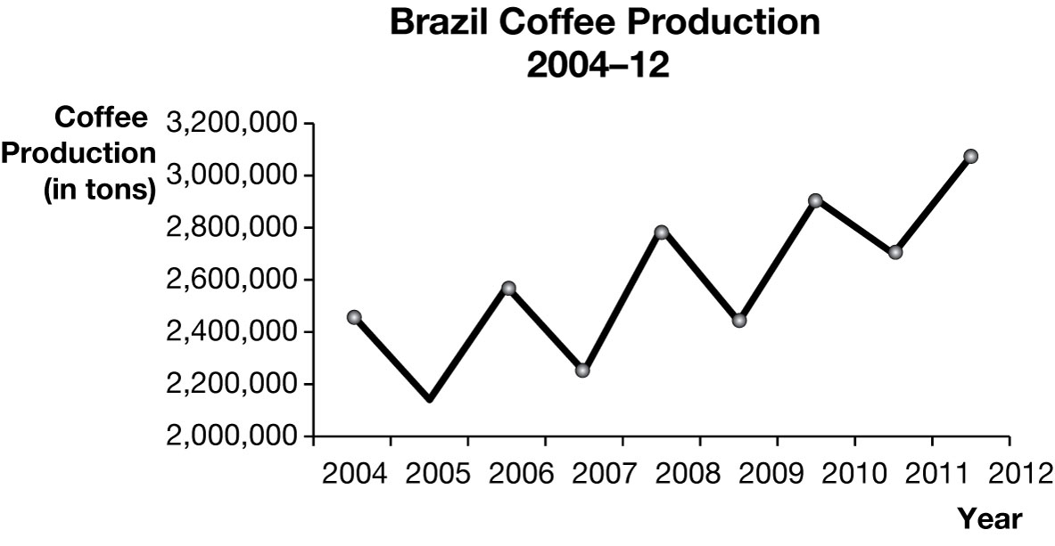
- The average quantity of coffee that Brazil produced during the 2009-11 period is 2,682,589 587 tons. This is the sum of the total quantity produced divided by the number of years.
- The coffee crop in 2012 is 14.6% larger than the average coffee crop in 2009-2011. The increase in production is 3,073,534 – 2,682,589 = 390,945. In percentage terms, the change is 390,945 / 2,682,589 587 = 14.6%.
Data taken from: http://faostat.fao.org/site/567/default.aspx#ancor
Suppose the following table shows the relationship between revenue that the Girl Scouts earn and the number of cookie boxes that they sell.
Number of cookie boxes | Revenue ($)
50 | 200
150 | 600
250 | 1,000
350 | 1,400
450 | 1,800
550 | 2,200
- Present the data in a scatter plot.
- Do the two variables have a positive relationship or do they have a negative relationship? Explain.
- What is the slope of the line that you get in the scatter plot? What does the slope imply about the price of a box of Girl Scout cookies?
Answer:
- The following line chart shows the relationship between the Girl Scouts’ revenue and the number of cookie boxes that they sell:
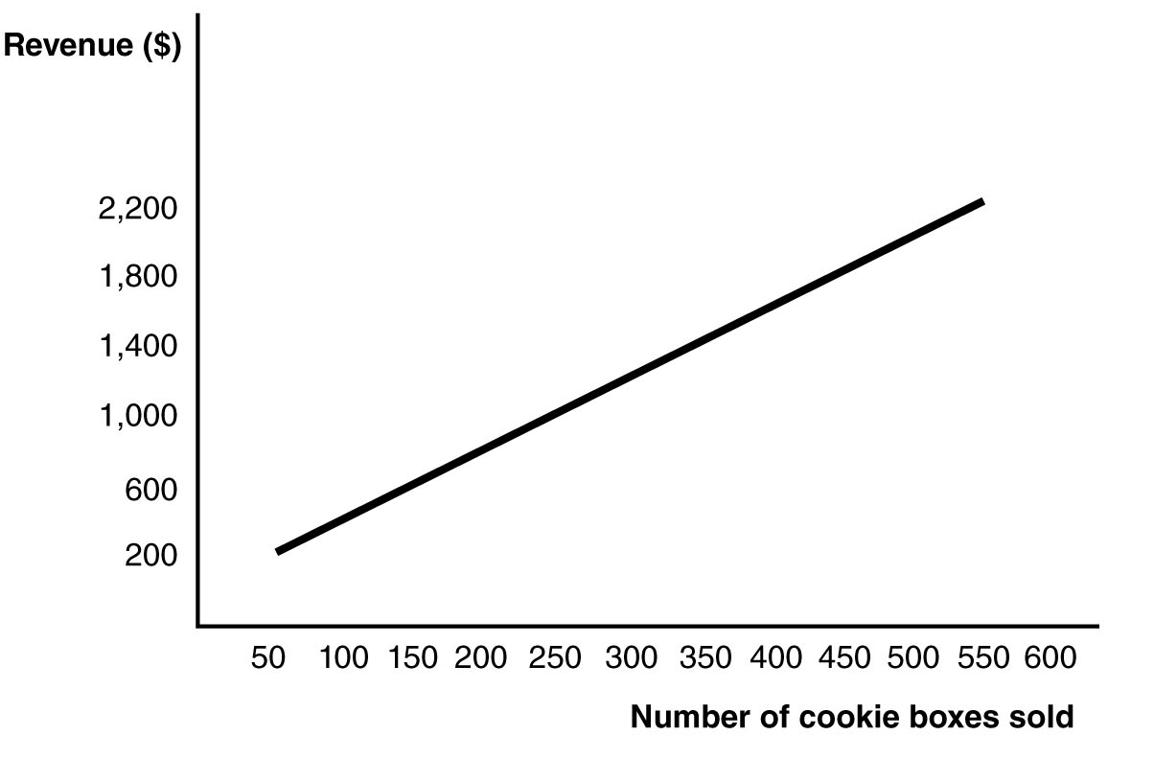
- Since the values of both variables increase together in the same direction, they have a positive relationship. This means that as more cookie boxes are sold, the revenue earned increases.
- The slope is constant in this problem and so we can choose any two points to calculate the slope. Suppose we use the first and last data points. The slope is calculated as . The slope implies that one extra box of cookies sold is associated with $4 more in revenue.

