Chapter 1
The Accounting Equation and Recording Journal Entries
Name: ______________________________
Class: ______________________________
Date: ______________________________

Display the Accounting Equation
- What represents amounts owed to entities outside of a business?
- Assets
- Liabilities
- Receivables
- Equity
- Which of these describes the accounting equation?
- Owner’s Equity = Profit - Liabilities
- Profit = Revenue / Liabilities
- Assets = Liabilities + Owner’s Equity
- Revenue = Equity * Assets

Enter Data and Numbers in Excel
- If the [Enter] key on the keyboard is used to complete this entry, where will the cursor move?
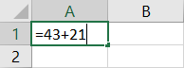
- A2
- B1
- B2
- It will remain in cell A1.
- If the [Tab] key is used to complete this entry, where will the cursor move?
- A2
- B1
- B2
- It will remain in cell A1.
- If the Enter button on the formula bar is used to complete this entry, where will the cursor move?
- A2
- B1
- B2
- It will remain in cell A1.
- Which of these is considered a constant value?
- 4,200
- =5+81
- =82*43
- =9/9
- The thick border surrounding an active cell is referred to as the _____.
- Ribbon
- entry
- reference
- highlight
- Match each keyboard key with the impact it has on the location of the active cell.
Keyboard Keys |  |  |  | Where the Active Cell Moves
A.  B. | (Enter)  [Tab] | _____  _____ |  | 1. | It will move to the next cell in the applicable direction.
C. | (←)(↓)(↑)(→) | _____ |  | 2. | It will move down to the next cell.
D. | (Esc) | _____ |  | 3. | The entry is deleted, and the cell remains active.
 |  |  |  | 4. | It will move to the next cell to the right.

Record Journal Entries
- Which statement is correct about debits?
- A journal entry can include only one debit.
- Debits are indented within a journal entry.
- A debit increases the balance within a revenue account.
- Debits appear above credits within a journal entry.
- What is NOT a standard component of a journal entry?
- Debited account
- Credited amount
- Accounting equation impact
- Explanation
- Which cell contains a long text entry?
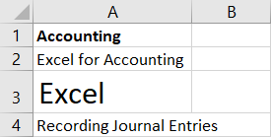
- A1
- A2
- A3
- A4
- Which cell contains a truncated long text entry?
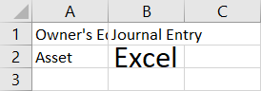
- A1
- A2
- B1
- B2
- What feature can be used to adjust the width of column A to accommodate the text in cell A1?
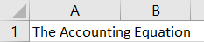
- Drag and drop
- Right-dragging
- AutoFit
- Paste Options
- What feature makes this menu appear?
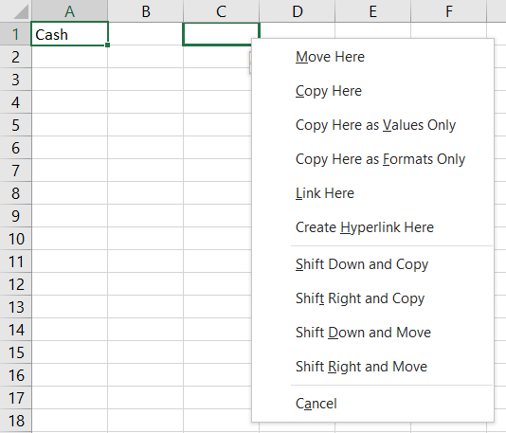
- Drag and drop
- Right-dragging
- AutoFit
- Paste Options
- Using drag and drop results in the same outcome as using _____.
- point and click
- Bold and Italic
- Undo and Redo
- Cut and Paste
- If the contents of cell A1 are copied and pasted into cell A3, what will appear in cell A3?
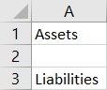
- Liabilities
- Nothing, the cell will be empty.
- Liabilities Assets
- Assets
- Match each Excel action with its associated description.
Actions |  |  |  |  | Descriptions
A.  B. | Drag and drop  Right-dragging | _____  _____ |  | 1. |  | Adjust column width (or row height) to accommodate the widest (or tallest) entry.
C.  D. | AutoFit  Copy and Paste | _____  _____ |  | 2. |  | Drag the outside border of a cell to move the contents to a new location.
 |  |  |  | 3. |  | Move the contents of a cell to a new location without dragging the border.
 |  |  |  | 4. |  | Drag the outside border of a cell to a new location to prompt a menu of options.

Use Undo and Redo in Excel
- Which actions cannot be undone?
- Right-dragging
- Saving a file
- Deleting text
- Changing the page orientation

- Maci notices that the Redo button is shaded and can’t be clicked, but the Undo button is active. Why?
- She hasn’t yet issued the Undo command.
- Excel hasn’t identified any errors for her to correct.
- She must have printed the file.
- You can only redo actions in the order you undid them.
- Tyler chooses the “Typing ‘Assets’ in A1” option from the Undo menu. What happens?
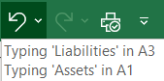
- The text “Assets” is removed from cell A1.
- The text “Liabilities” is removed from cell A3.
- The text in both cell A1 and cell A3 is removed.
- Nothing; he has to undo actions from top to bottom in the list.
- What action results in this ScreenTip being displayed?
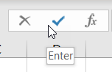
- Hovering the mouse pointer over the Enter button
- Clicking the Enter button and dragging down
- Clicking the Enter button
- Right-clicking the Enter button

Print Worksheets
- What action cannot be done in Backstage view?
- Altering the print options
- Viewing a preview of the printout
- Navigating through the previewed worksheet pages
- Editing the worksheet
- What page orientation is this?

- Portrait
- Horizontal
- Accounting
- Landscape

- Match each Ribbon option with its associated description.
Ribbon Options |  |  |  | Descriptions
A. | Orientation | _____ |  | 1. | Changes the page dimensions
B.  C. | Size  Print Area | _____  _____ |  | 2. | Sets where one printed page ends and the next begins
D. | Breaks | _____ |  | 3. | Sets the page layout to either portrait or landscape
 |  |  |  | 4. | Allows you to identify a range of cells that will be printed
- Braedon completed his worksheet and is in a rush to print a portion of it, so he clicks the Quick Print button. What happens next?
- Backstage view is displayed so he can choose the print options.
- The worksheet is sent to the printer with the current print options in effect.
- A menu is displayed from within the available print options for this worksheet.
- The print preview appears.

